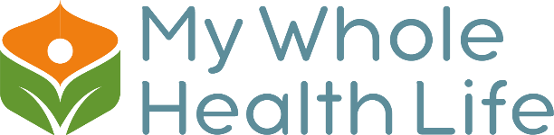

My Whole health Life, LLC
6965 Piazza Grande Ave. Suite 412
Orlando, FL 32835
Tel: 407-203-5090
E-mail: contact@mywholehealthlife.com
Website: www.mywholehealthlife.com

Authorization of Release

I, ____________________________________, hereby authorize Dr. Cleyde Crofoot,

LCCC, at My Whole Health Life, LLC, located at 6965 Piazza Grande Ave. Orlando, FL

32835 to: Release To __________________________Release from ____________

Exchange Written and/or Oral Communication ______ Psychiatric ______ Medical

______ Psychological ______ Counseling from the records of: __________________

Name of Client _________________________ Date of Birth____________________

To: __________________________________________________________________

For: Outpatient Counseling. Coordination with schools. Send Thanks you Card, for Referral. Coordination with MD/Psychologist/OT Therapist/Therapist. I understand that under state and Federal confidentiality provisions only the above specified information can be released to only the above specified person or agency. I also understand that I may revoke this release of information at any time, providing that I notify the authorized agency in writing to this effect, but that revocation has no effect on action previously taken.

This consent will expire on __________________ _____________________________

Client, Parent, Guardian____________________________ Date_________________

Witness_________________________________ Date________________________

